**Computing: Coding**

What your child should know –

* how to use variables in their code
* how to plan an algorithm modelling the sequence of traffic lights
* how to create a program and select the right images to reflect the simulation they are making
* some ways that text variable can be used in coding

**PSHE:**

What your child should know –

* that people can feel alone and misunderstand: learn to give appropriate support
* how to develop strategies for understanding, managing and controlling strong feelings and emotions (such as grief) and dealing with negative pressures
* how to manage conflict

**P.E**

What your child should know –

* how to demonstrate agility, balance, coordination and precision.
* how to apply skills effectively in different situations
* how to work alongside and against others when attacking and defending.
* how to throw, catch and field.

**Art – Wire Sculpture**

What your child should know-

* How to use tools carefully and safely
* How to use wire to create their own sculptures
* How to use papier-mâché and other materials to create a 3D effect

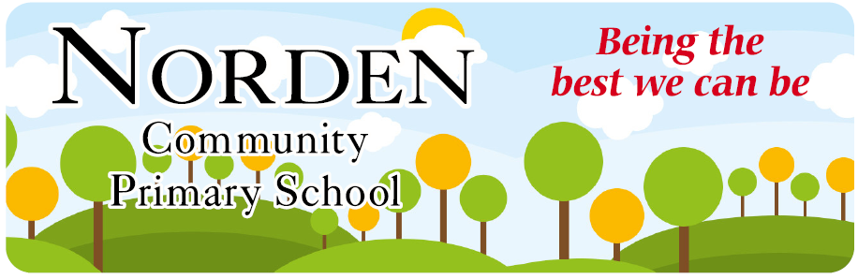

**Curriculum Newsletter**

Term – Autumn 2 Year 5

Hi Everyone,

It has been lovely to welcome the children back for another half term. We have lots to look forward to: Science investigations, Maths challenges, our new History unit of learning about the Anglo-Saxons and Vikings, as well as Art where we will be creating a Wire Sculpture. We would like to thank you for your continued support: helping the children at home with their homework makes such a difference and we do appreciate how busy life can be.

Future showcase dates (subject to change): Wednesday 12th February and Wednesday 21st May 2025.

Mrs McCreary and Miss Hatton.

|  |  |  |  |  |
| --- | --- | --- | --- | --- |
| **MON** | **TUES** | **WED** | **THURS** | **FRI** |
| PE 5H  5M |  | PE 5M | PE 5H | Reading, Spellings, Maths homework.  Spelling test in school and new spellings set. |

**English**

**What your child should know-**

* how to identify the purpose and audience for their writing – alternative retell and non-chronological report.
* different word classes (noun, verb, adjective, adverb and pronoun) expanded noun phrases and sentence structures, including complex sentences and the use of relative clauses
* how to use modal verbs, alliteration, adverbial phrases, puns, headings, sub-headings and rhetorical questions
* the impact of formal and informal language

**Unit of Learning (History) – Anglo-Saxons and Vikings**

What your child should know -

* Know about how the Anglo-Saxons attempted to bring about law and order into the country
* Know that during the Anglo-Saxon period, Britain was divided into many kingdoms
* Know that the way the kingdoms were divided led to the creation of some of our county boundaries today
* Know where the Vikings originated from and show this on a map

h

**Science – Reversible and Irreversible Changes.**

What your child should know –

* About the life cycle of a human being.
* What the terms puberty, gestation and reproduction mean.
* The life cycle of different living things, e.g. mammal, amphibian, insect and bird.
* About the process of reproduction in plants.
* About the process of reproduction in animals.

**Music**

What your child should know –

(Continued from Autumn 1)

* How to appreciate the listening and appraising of classical music.
* The impact of the instruments played within a song on atmosphere, feelings and emotions.
* How to compose music using sounds identified with symbols

**R.E. Why do some people believe God exists**

What your child should know –

(Continued from Autumn 1)

* examples which show how believing in God can affect people’s lives differently
* how to express their ideas about theism, atheism and agnosticism
* how to consider reasons that people might believe or not believe in God
* how interpretation can lead to the coming about of facts, beliefs and opinions

**Maths- Multiplication and Division**

What your child should know –

* how to use the grid and standard method for multiplying a 2, 3 and 4 digit numbers by a single digit, 2 digit and 3 digit number
* how to use the standard method for dividing a 2, 3 and 4 digit numbers by a single digit and divisions with remainders
* an improper fraction and mixed number and how to convert between them