**Computing: Online Safety**

What your child should know –

* the impact that sharing digital content can have: their responsibility to one another in their online behaviour
* the advantages, disadvantages, permissions and purposes of altering an image digitally: how to maintain secure passwords
* the impact of sharing appropriate and inappropriate text, photographs and videos online

**PSHE:**

What your child should know –

* recognise their strengths and weaknesses and how they contribute to different groups
* reflect on past achievements and how to work collaboratively towards common goals
* identify how behaviour and that of others may influence people both positively and negatively

**P.E**

What your child should know –

Tennis:

* How to grip a racket effectively
* Perform forehand and backhand shots
* Serve to re-start a game
* Scoring rules within Tennis

Basketball:

* Dribble the ball using both hands
* Perform a chest and bounce pass
* How to defend an opponent
* How to effectively shoot

**Art – 3D Clay Sculpture**

What your child should know –

* Use a range of tools to create detail and precise markings
* Use strengthening techniques to join clay
* Create 3D facial features

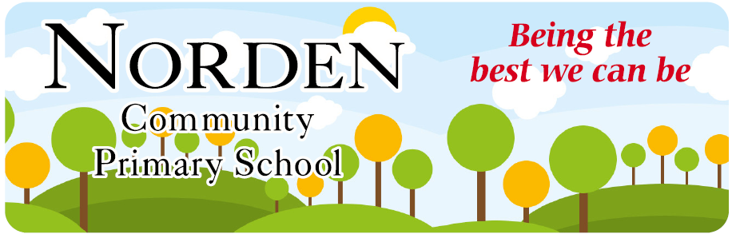

**Curriculum Newsletter**

Term – Autumn 1 Year 6

Hi Everyone,

We are delighted to welcome the children back for a new school year. We hope the children are excited to continue their learning in a warm, safe and encouraging environment. We have no doubt that the children will embrace their new role of being the oldest children in school with great maturity, acting as role models for the younger pupils. We are very much looking forward to a great year with your children, supporting them in achieving their full potential. As always, many thanks for your continued support and we look forward to working together as a team this year.

Mr Cleverly and Mr Dench

|  |  |  |  |  |
| --- | --- | --- | --- | --- |
| **MON** | **TUES** | **WED** | **THURS** | **FRI** |
| P.E Class 6C and 6D |  |  | P.E. Class 6C and 6D | Reading, Spellings & Maths homework handed in.  Spelling test and new spellings set. |

**Geography – What are the main features of South America?**

What your child should know -

* The names and key features of South American Countries
* The physical and human features of Brazil
* How time zones work in South America
* Trade links and economic growth in Brazil

**English**

**What your child should know-**

* Write a diary entry
* Produce a non-chronological report on South America
* Different word classes: nouns, adjectives, verbs, adverbs, and pronouns
* Different sentence types: simple, compound and complex
* The different features of formal and informal writing

**R.E. What do religions say to us when life gets hard?**

What your child should know –

* Questions about life, death and suffering and what matters most in life
* Recognise the role that religions have in helping people when the going gets tough
* Understand what Christians, Hindus and non-believers say about life after death and explain similarities and differences between their beliefs
* Understand how different people cope with bereavement

**Science – Electricity – how does it work and how does its power vary?**

What your child should know –

* How does electrical energy vary
* What is meant by electrical particles
* Which symbols are used to represent different parts of a simple circuit and how they can be constructed
* Wow to make use of knowledge of circuits to create a simple game

**Maths- Place value and the four operations**

What your child should know –

* Numbers to ten million
* How to compare and order any number
* How to round any number
* Negative numbers
* How to add and subtract whole numbers
* How to multiply up to 4 digits by a 1-digit number
* How to calculate short division
* Common factors, common multiples and prime numbers